CHALLENGING EXPERIMENT 6

15BCE0517

M.S.SANJAY

1)

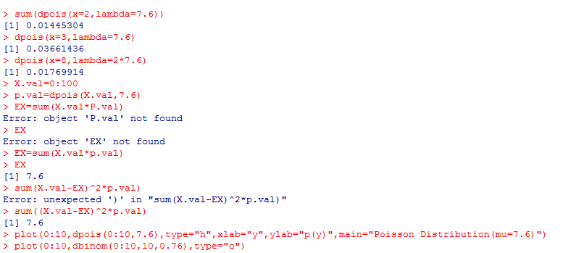

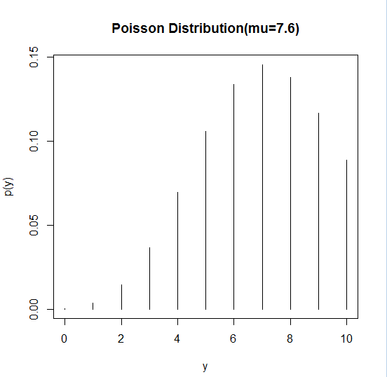

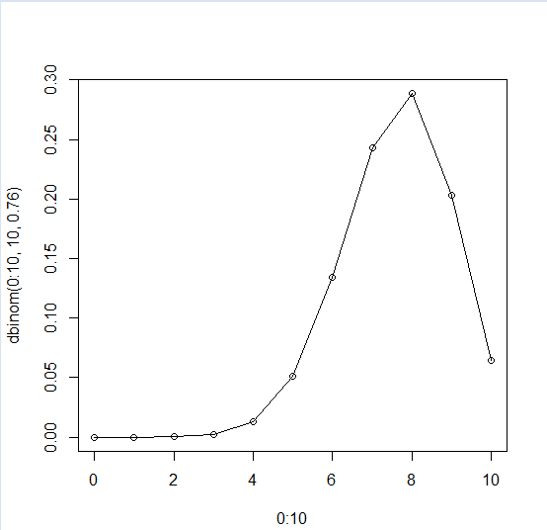

2 )

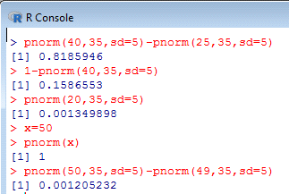

Answers:

i) 0.8185946

ii) 0.1586553

iii) 0.001349898

iv) 0.001205232

3)

H0: pbar=p0

H1: pbar~=p0

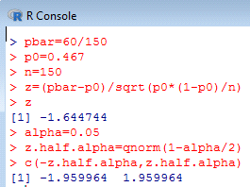

*Conclusion: The test statistic -1.644744 lies between the critical values -1.959964 and 1.959964. Hence, at .05 significance level, we do not reject the null hypothesis that percent of girls born in china is 46.7.*

4.)

H0: pbar=p0

H1: pbar~=p0

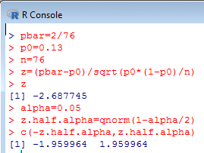

*Conclusion: The test statistic -2.687745 does not lies between the critical values -1.959964 and 1.959964. Hence, at .05 significance level, we reject the null hypothesis that we do not agree with the newsweek poll.*